**Requirements, Analysis and Design Models**

**Bank Web Application**

**Name: Aaron Fu Siang Ann**

Table of Contents

Requirements Model 1

Use Case Diagram 1

Use Case Description 2

Use Case 1 2

Use Case 2 3

Use Case 3 3

Analysis Model 4

Class Diagram 4

Sequence Diagram 5

Sequence Diagram 1 5

Sequence Diagram 2 6

Sequence Diagram 3 7

# Requirements Model

## Use Case Diagram

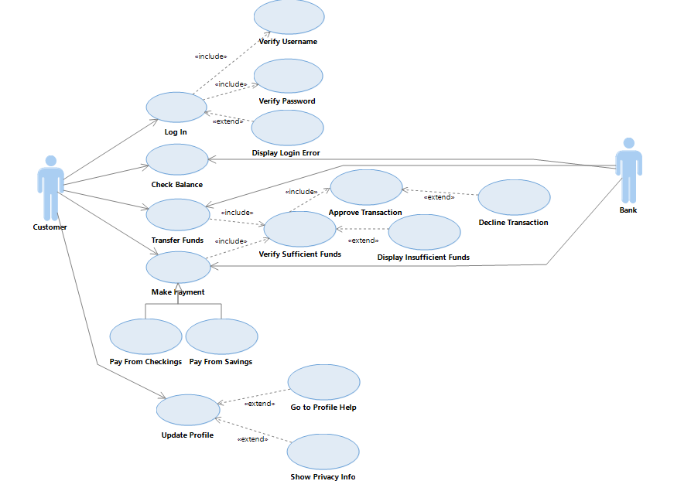

## Use Case Description

### Use Case 1

|  |  |
| --- | --- |
| **Use Case Name** | **Login** |
| Use Case Description | A user login to access their bank account |
| Actors | Customer |
| Pre-Condition | User already has an account |
| Post-Condition | Successful login to bank account and view menu |

|  |  |  |
| --- | --- | --- |
| **Main Scenarios** | **Serial No** | **Steps** |
| Actors/Users | 1 | Enter username |
|  |  | Enter password |
|  | 2 | Verify username and password |
|  | 3 | Allow access to bank account |
| Extensions | 2a | Invalid username |
|  |  | Display login error |
|  | 2b | Invalid password |
|  |  | Display login error |

### Use Case 2

|  |  |
| --- | --- |
| **Use Case Name** | **Check Balance** |
| Use Case Description | A customer checks account balance |
| Actors | Customer, Bank |
| Pre-Condition | Customer login successfully |
| Post-Condition | Successful viewed account balance |

|  |  |  |
| --- | --- | --- |
| **Main Scenarios** | **Serial No** | **Steps** |
| Actors/Users | 1 | Choose check balance option |
|  | 2 | Bank gets balance for customer |
|  | 3 | Bank returns balance |
|  | 4 | Display balance on screen for customer |

### Use Case 3

|  |  |
| --- | --- |
| **Use Case Name** | **Transfer Funds** |
| Use Case Description | Customer transfer funds to another bank account |
| Actors | Customer, Bank |
| Pre-Condition | Customer successfully login  Customer has sufficient funds |
| Post-Condition | Successful transfer funds to another bank account |

|  |  |  |
| --- | --- | --- |
| **Main Scenarios** | **Serial No** | **Steps** |
| Actors/Users | 1 | Customer choose transfer funds option |
|  | 2 | Enter bank account to transfer |
|  | 3 | Enter amount to transfer |
|  | 4 | Bank verify sufficient funds |
|  | 5 | Customer confirms and approve transaction |
|  | 6 | Funds successfully transferred |
| Extensions | 4a | Insufficient Funds |
|  |  | Display Insufficient Funds error |
|  | 5b | Customer declines transaction |

# Analysis Model

## Class Diagram

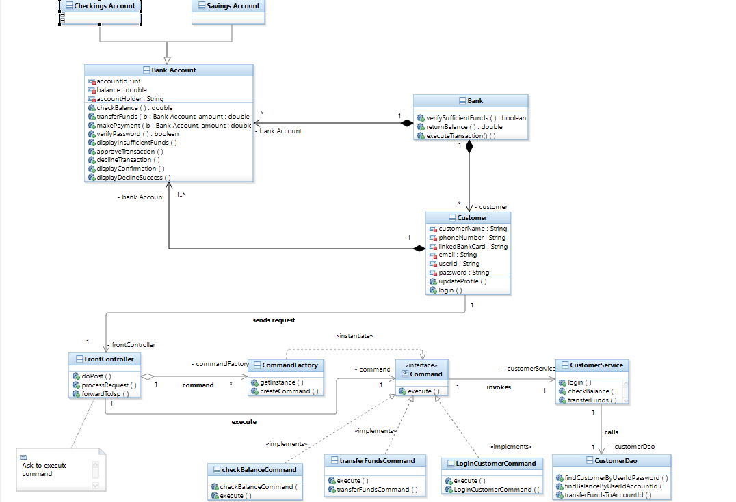

## Sequence Diagram

### Sequence Diagram 1

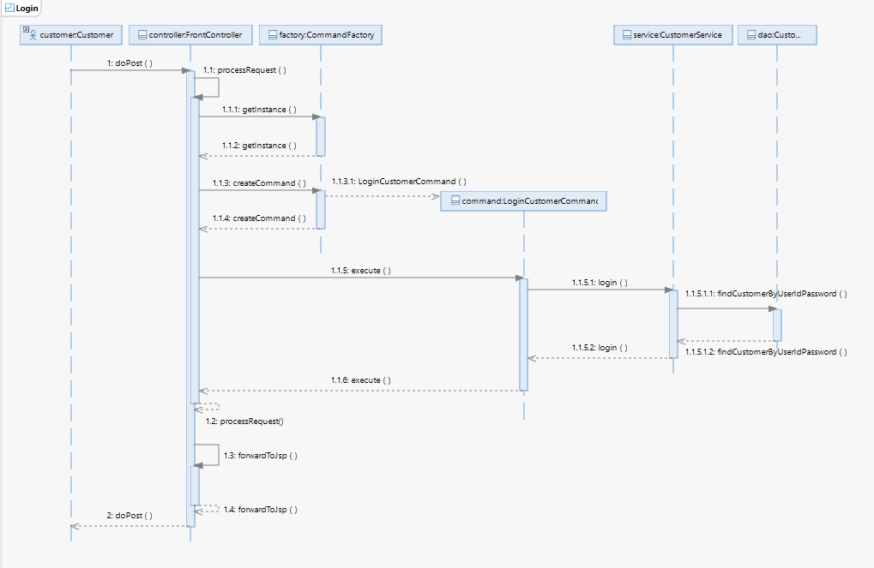

### Sequence Diagram 2

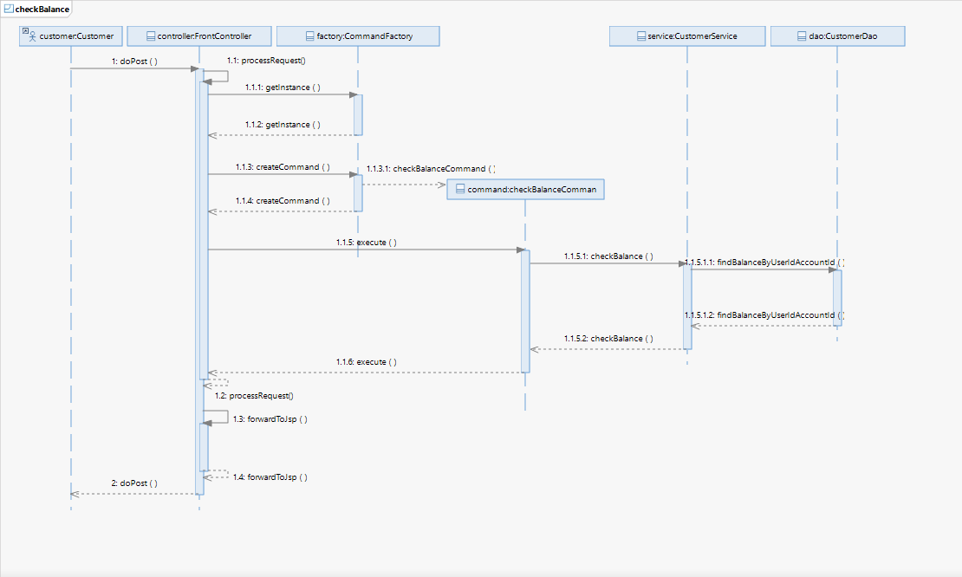

### Sequence Diagram 3

